Button on NSPOS that will prompt and ask you a gift card number, and then that with that giftcard number gives you all the data from that gift card

Account: Goodwill Industries Orange County sb

If we go to UVA
If we press view

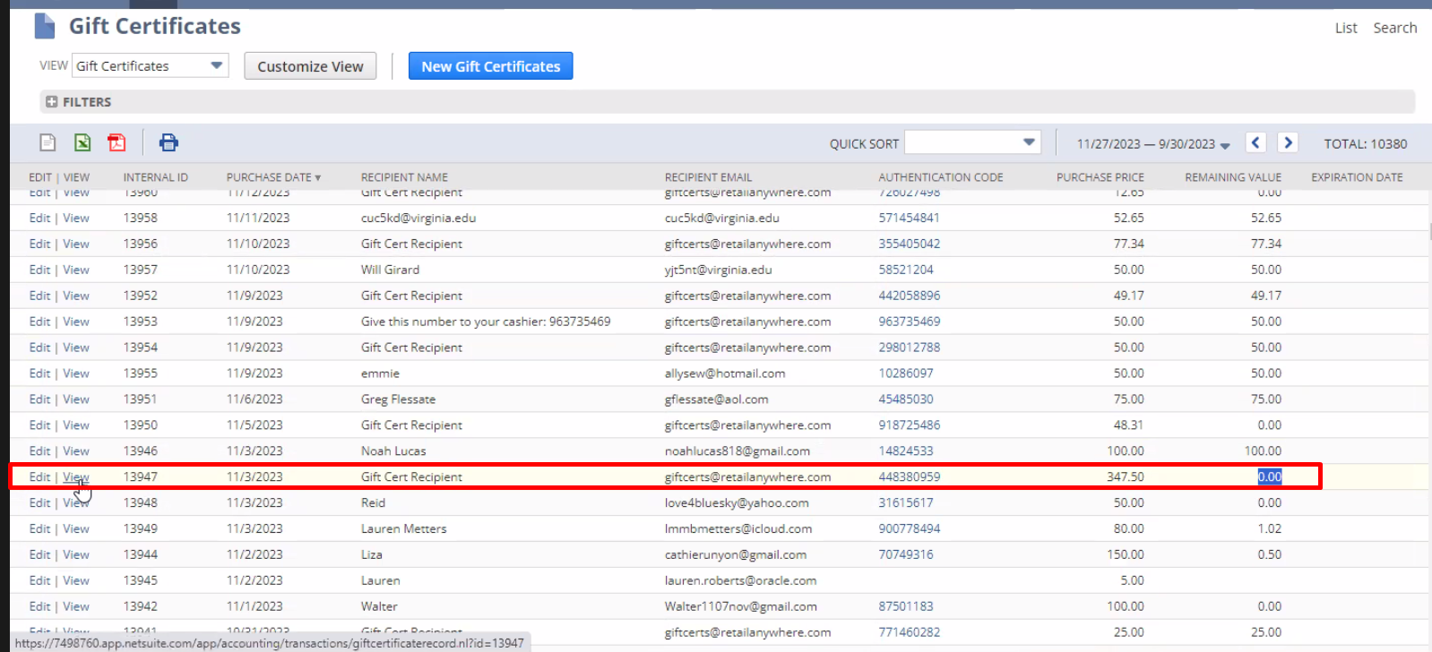
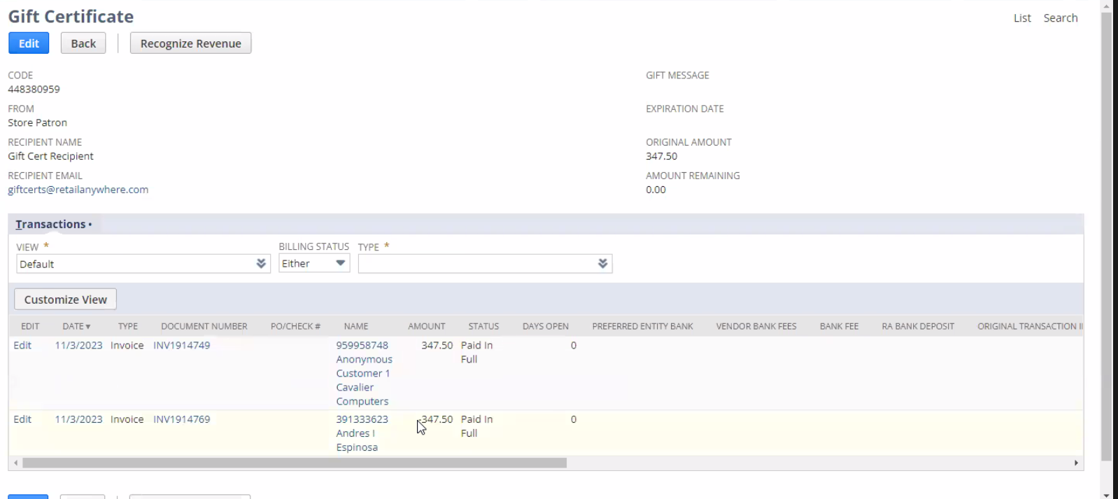

You need

Pull all transaction information from the gift card number.

Created the search:
Gift Card Transaction History Saved Search

All gift cards transaction for that gift card number.

1 that shows line items

2 that shows what transactions have been used and for how much.

